As shown in the image below, Team 1 decided to use the space and material that they had to weld together a book. The purpose of this welded book is to serve as decoration for Rachel’s room as she is a reader and really enjoys books.

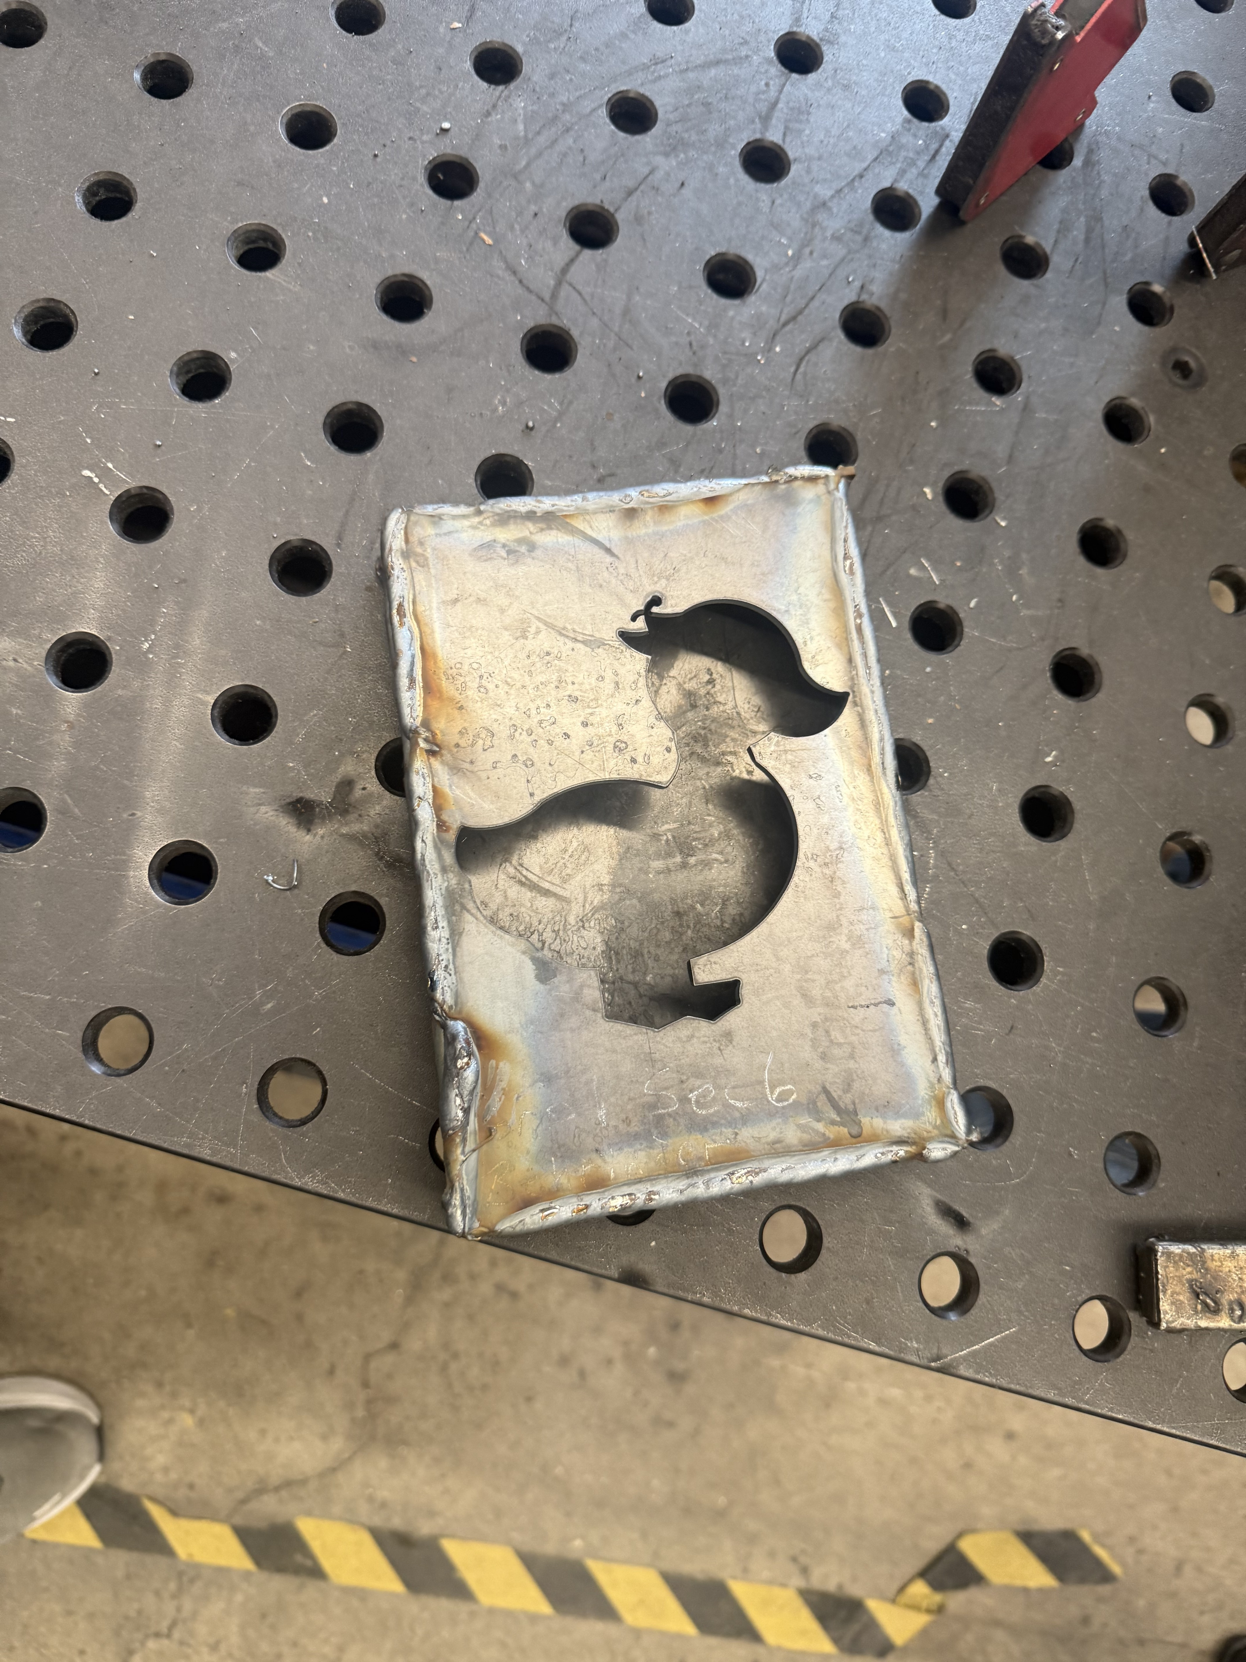

One improvement that could be made is the misalignment that occurred with some of the pieces of the book. As you can see in the image below, there are top and bottom pieces that jut-out farther than the end of the book, however, those pieces are not meant to do that. The group does not know if their piece sizing was off, or if it was a misprint, but either way, that could be improved.

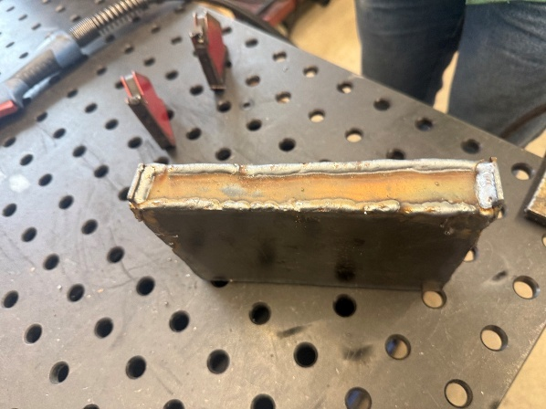

Next time around all sides could be flush with each other and the book would not have ends jutting out. To fix this, the group could resize the top and end pieces (should that have been the problem), or, should it be a misprint, the group could trim the pieces in the shop (like they had to do to a different piece) so that the book would fit together all the way around.

Another improvement that could be made is to the fabrication itself. If the group had any experience welding then it is highly likely that the book would have come out much cleaner looking than it did. Out of all of Team 1, there was only one person that had prior welding experience so that hindered the aesthetics of the book since most of the group was welding for the first time. To improve on this, members could go down to the weld shop beforehand to spend more time practicing so that they better understand the more niche things about welding, such as height from the part, speed, and the looped pattern of moving. A better understanding of these things, and more practice, would significantly improve the look and weld of the part.

One lesson the group learned from this project was about welding itself. The group took note that welding itself is not difficult, but what makes welders so good is the time they have put into their craft. What brought this idea on is that the group noticed how each person’s welds got better and better as time went on, which made the group realize that the most important thing in good welding is practice. Most of the group had just learned welding, but they felt confident that they could do significantly better if they had more practice and had spent time welding before.

Another lesson the group learned is the importance of verifying piece dimension so that all pieces are the size they are meant to be. The group realized on the welding day that some of the pieces were incorrectly cut. To avoid this, the group could have come in beforehand and did an assembly of the book to make sure the parts fit properly. Correct sizing is so incredibly important because now the book does not look as it is meant to. This problem is bearable for this project because the book is simply a decoration. However, in a manufacturing setting, this would be a significant problem, because this wrongly sized part would cause issues to occur in the machine that could become dangerous for workers. Besides the workers, it could also damage equipment which is a significant expense to a company.

